### 

### ABSTRACT

Bitcoin is the world's first completely decentralized digital payment system, the emergence of bitcoin represents a revolutionary phenomenon in financial markets. This paper mainly studies the relationship between bitcoin and crude oil prices. A multivariate analysis between bitcoin and crude oil was carried out to establish the relationship between bitcoin and crude oil. Cointegration analysis, VAR and ARDL models were considered for the research. Also, univariate analysis was carried out to establish the effect of past values on bitcoin and future prices are forecasted.

### INTRODUCTION

Our research was based on analyzing the economic relationship between Bitcoin and Crude Oil prices. Bitcoin is a form of digital asset, that is created and held electronically. The system is peer-to-peer, and the transactions happen directly among users without an intermediary. No one has control over it or prints it unlike USD or INR. Bitcoin has exhibited large volatility in a short period. The price of bitcoin has gone through cycles of bubbles and busts.

Bitcoin was quite cheap at its birth, only about 5 cents per Bitcoin. But with the promotion of its influence around the world, its price boomed. In 2013, with the personal virtual currency regulation, which admitted the legal status of Bitcoin, and the Bitcoin price raised to more than $1000. With the global bitcoin, hot the demand of bitcoin in China increased, further increasing the Bitcoin prices to a historic $1151 [1].

This paper mainly studies the price fluctuations of Bitcoin and discusses its variation with the crude oil prices.

### VARIABLE SELECTION

It is since 2011 that Bitcoin price began to fluctuate significantly and attract increasing attention. So, the sample period we choose is from August 2011 to October 2016, too much noise exists in the data before 2011 due to the small trading volume. Since dollar is a major foreign exchange currency of Bitcoin, we use the exchange rate of Bitcoin and dollar to represent the price of Bitcoin. When measuring the Crude oil price, we chose the WTI crude oil price, which is a benchmark in crude oil prices. As there is a huge fluctuation in the data, logarithmic treatment to the Bitcoin price, oil price is conducted. Data stream is used to download the weekly data for Bitcoin and WTI crude oil prices from august 2011 to October 2016. Eviews is used for statistical analysis.

### EMPIRICAL RESEARCH

### STATIONARITY TEST OF VARIABLES

### LINE GRAPH AT LEVEL



At level, Bitcoin seems to be violating the conditions for stationarity, with a visible upward trend and exhibits structural breaks in the mid 2013 to 2014.



At level, Crude Oil seems to be violating the conditions for stationarity. The mean seems to be varying over time. And, exhibits structural breaks in the early 2014 to mid-2014.

LINE GRAPH AFTER LOG TRANSFORMATION



Even after the log transformation, the bitcoin series doesn’t seem stationary.



Even after the log transformation, the crude oil series too doesn’t seem stationary.

### LINE GRAPH AFTER FIRST DIFFERENCE



On taking first difference of the original series, the bitcoin series seems to satisfy the stationarity restrictions.



Likewise, on taking first difference on the original crude oil series seems to look stationary.

### UNIT ROOT TEST

To estimate the stationarity of the variables under study, we performed Break point unit root test for data with structural breaks on both Bitcoin and Crude Oil.

**Bitcoin – Break Point**



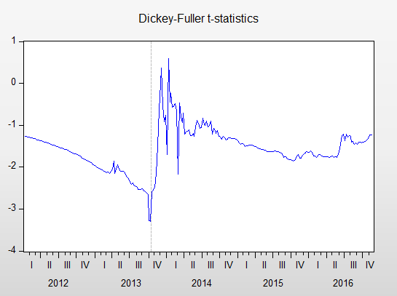 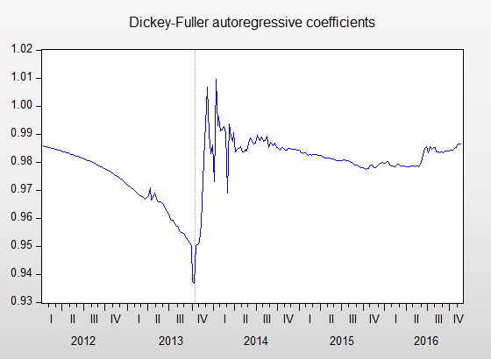

The test captures the structural breaks in August 2013. And the P value of 0.5096 assures that the series is non-stationary indeed.

### UNIT ROOT TEST AT FIRST DIFFERENCE

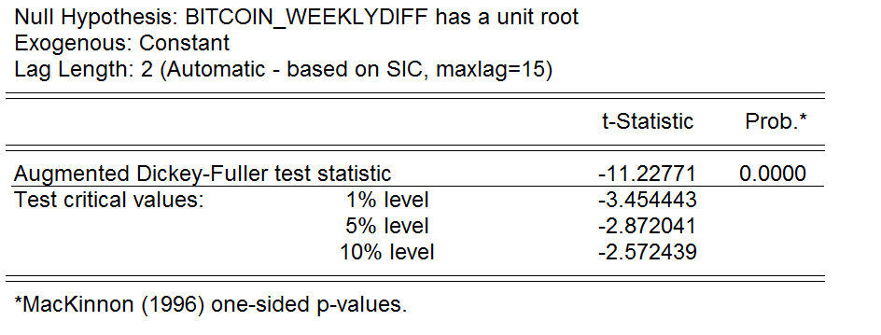

Unit root test indicates a clear stationarity at first difference.

**Oil – Break Point**



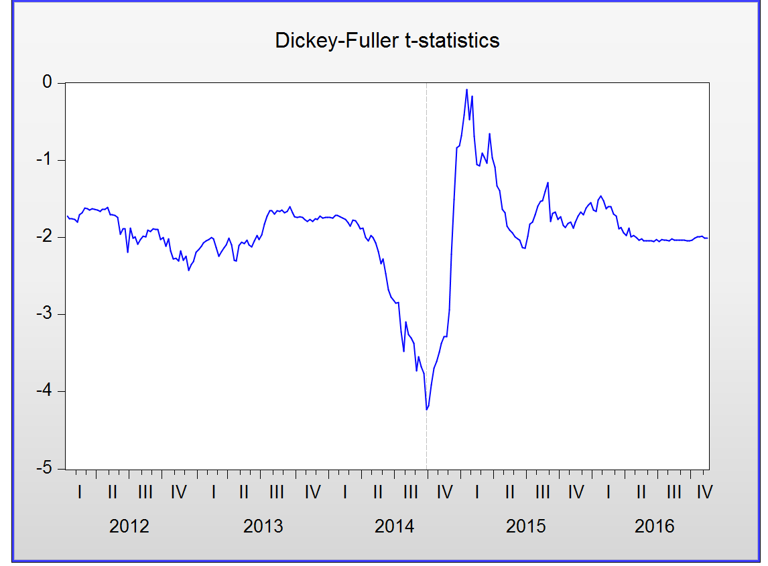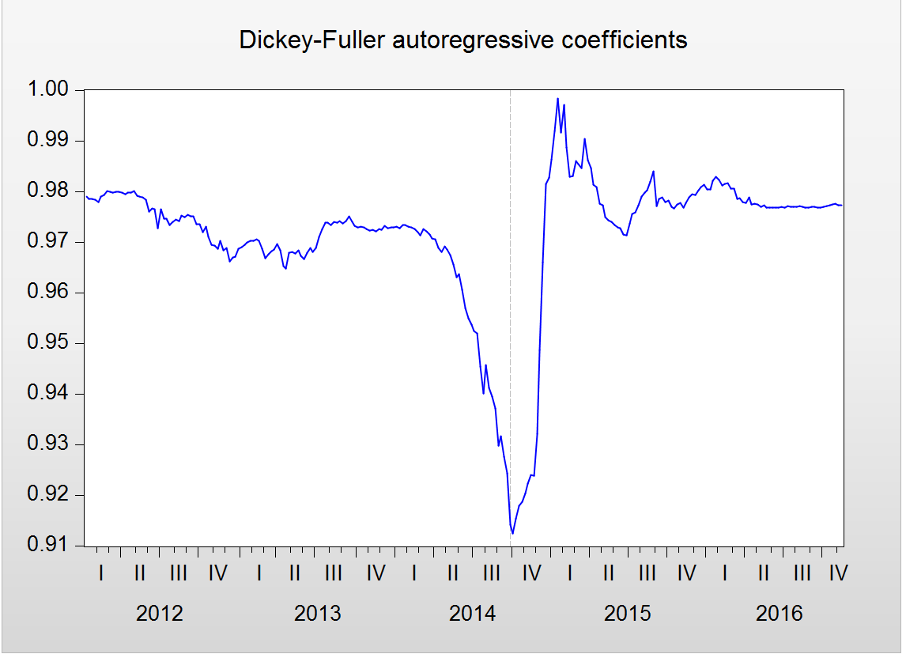

The test captures the structural breaks in October 2014. And a highly significant test statistic of -4.23 assures that the series is non-stationary indeed.

### UNIT ROOT TEST AT FIRST DIFFERENCE

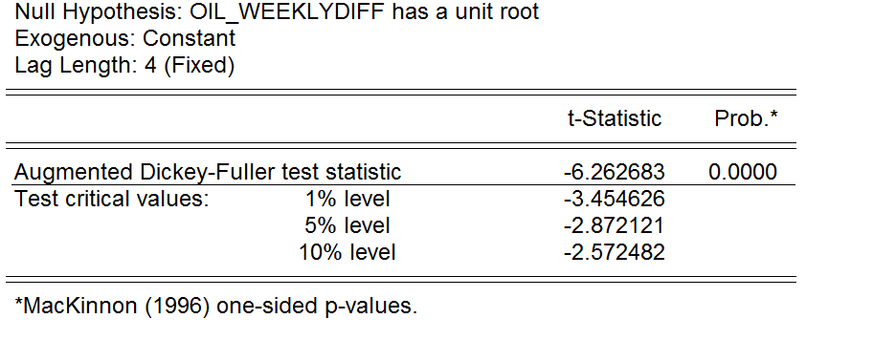

Oil at first difference is clearly stationary.

# MULTIVARIATE ANALYSIS OF BITCOIN AND CRUDE OIL

### COINTEGERATION

The two variables are stationary series after the first order difference, so the Johansen method can be used for cointegration test. Cointegration relationship among variables can be determined through trace statistic and the maximum eigenvalue likelihood ratio statistic.

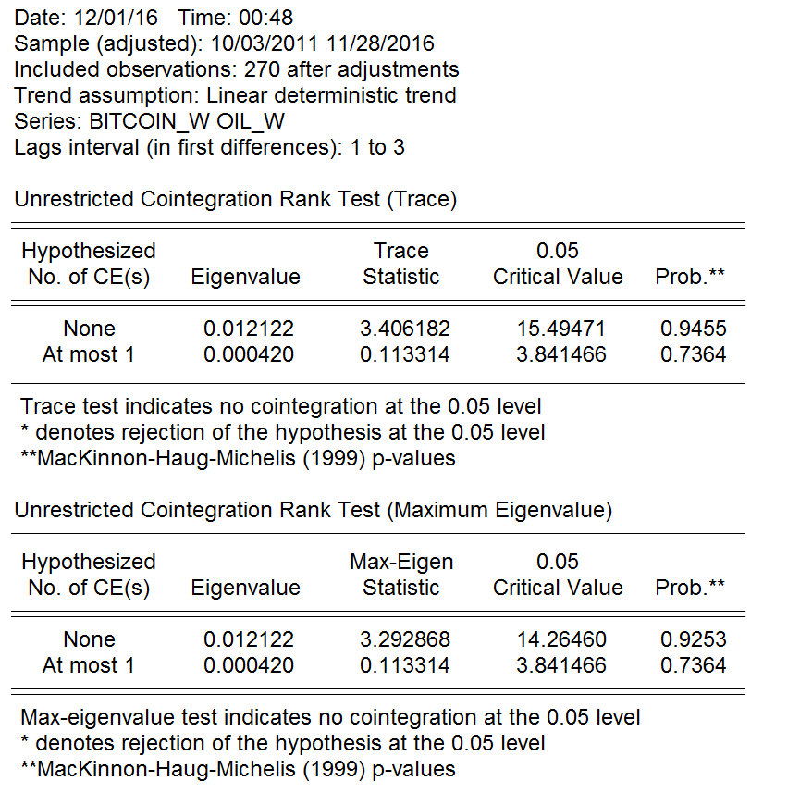

Both Trace and eigen values indicates no co-integration at the 0.05 level.

### VAR MODEL ESTIMATION

### LAG LENGTH SELECTION

Before doing VAR analysis it is essential to estimate the lag length of the model, Based on the estimation, a VAR (3) analysis is suitable for estimation.

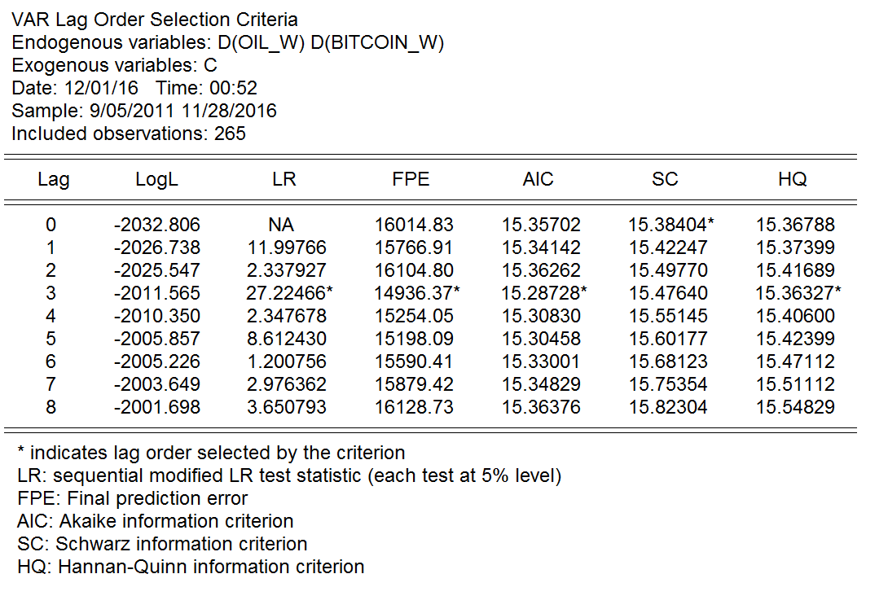

### DUMMY VARIABLES

There's a clear structural break in the data, hence a dummy variable, BREAK, is added that takes the value 1 for these observations, and 0 everywhere else. The structural break variable is included while running the tests for better model selection.

### VAR ESTIMATION

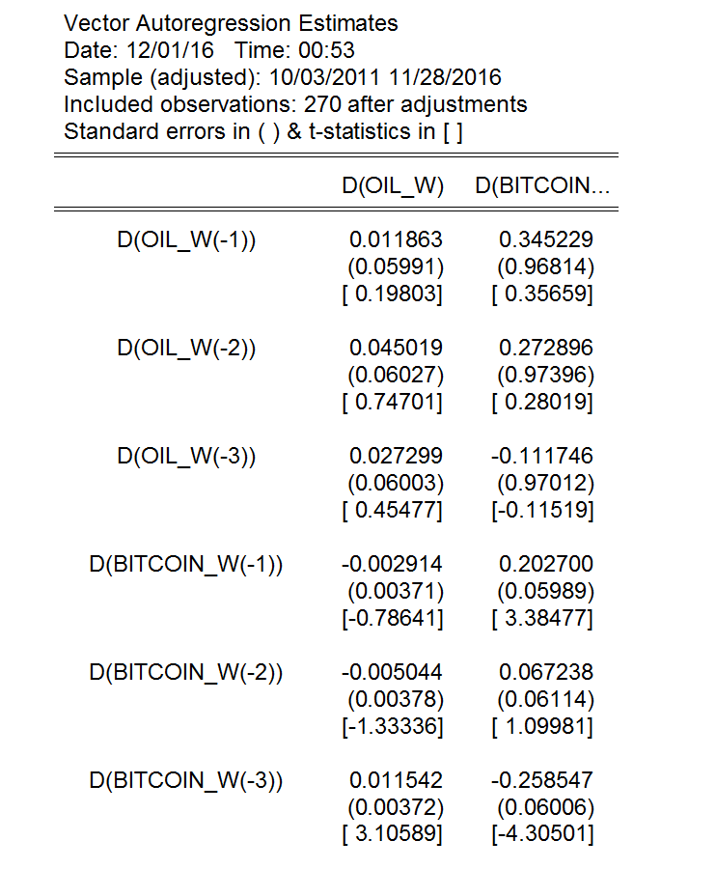

Running a VAR (3) model, we can see that Bitcoin is highly significant onto itself. We can also see that oil is significant onto Bitcoin (-3).

### SERIAL CORRELATION

Once the model is estimated it is important to make sure that there is no serial correlation in the residuals. Based on the LM test we can confirm that there is no serial correlation at lag length 3 and so the estimates are not biased.

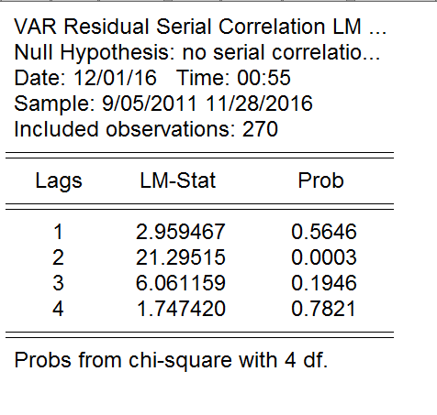

### IMPULSE RESPONSE

Impulse-response functions (IRFs) can be used to estimate the effects of an exogenous shock to a single variable on the dynamic paths of all the variables of the system. We can see that the shocks from oil onto bit coin is significant in short period but slowly decays with time.



## ARDL MODEL ESTIMATION

### GRANGER CAUSALITY

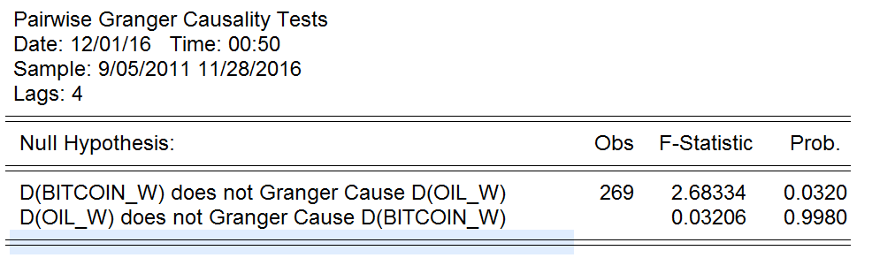

Granger causality test indicates that bitcoin Granger causes oil. Based on this a ARDL model can be estimated for the model.

### LAG LENGTH SELECTION

Based on the Akaike information criteria an ARDL(1,3) has the least AIC value.

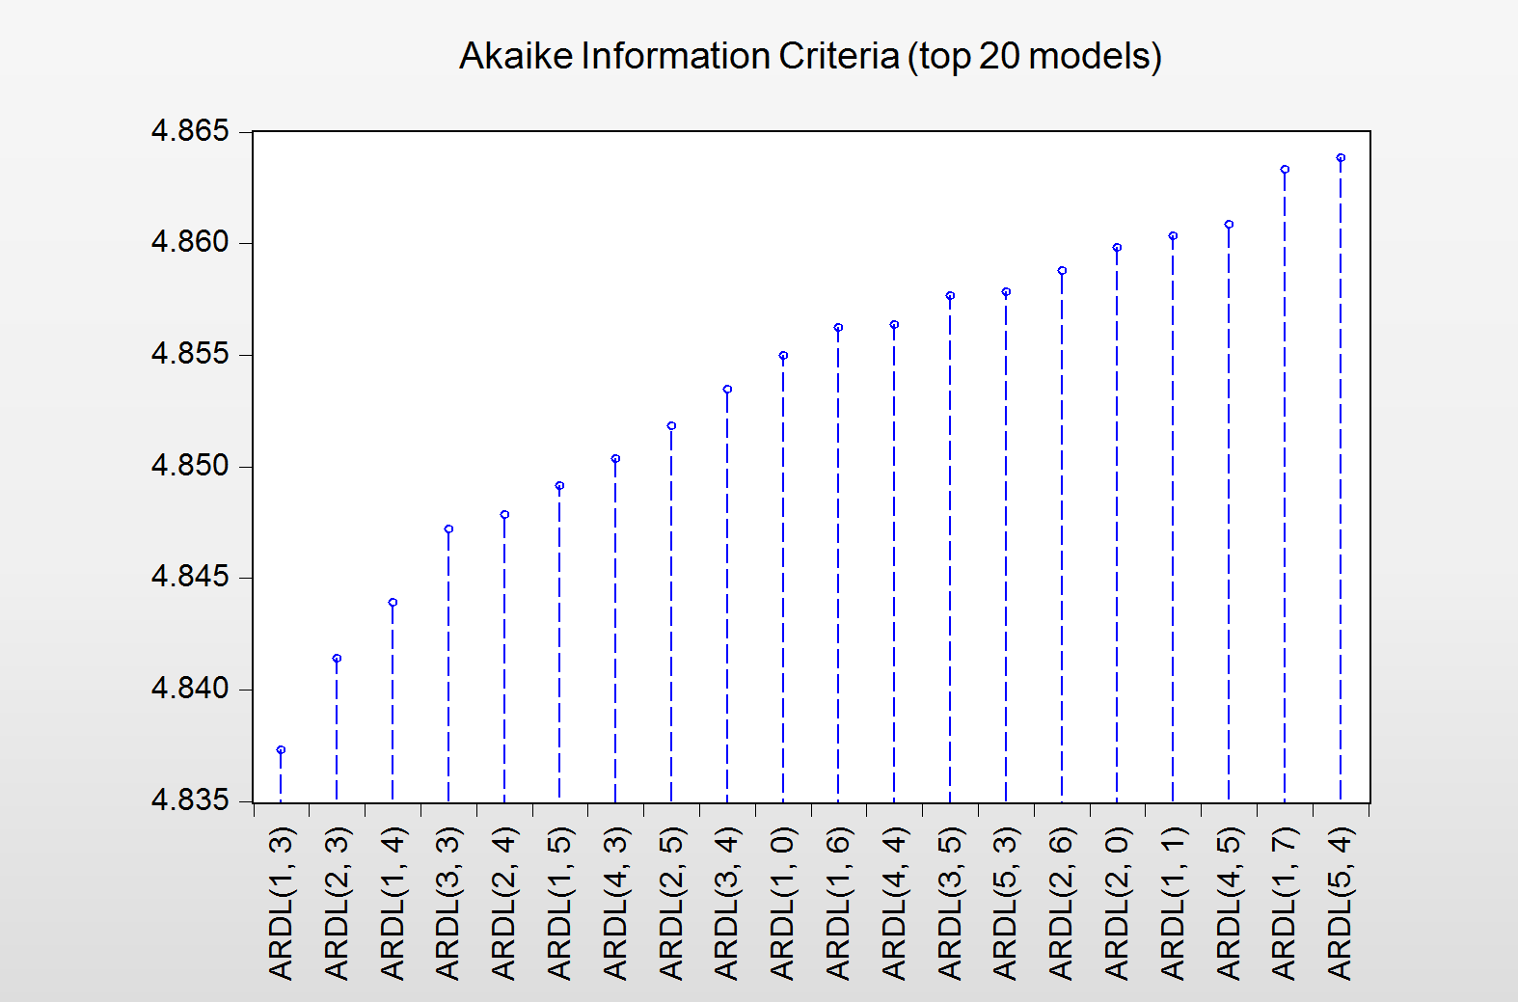

### ARDL(1,3)

The estimated model suggest that oil is significant onto bitcoin(-3).

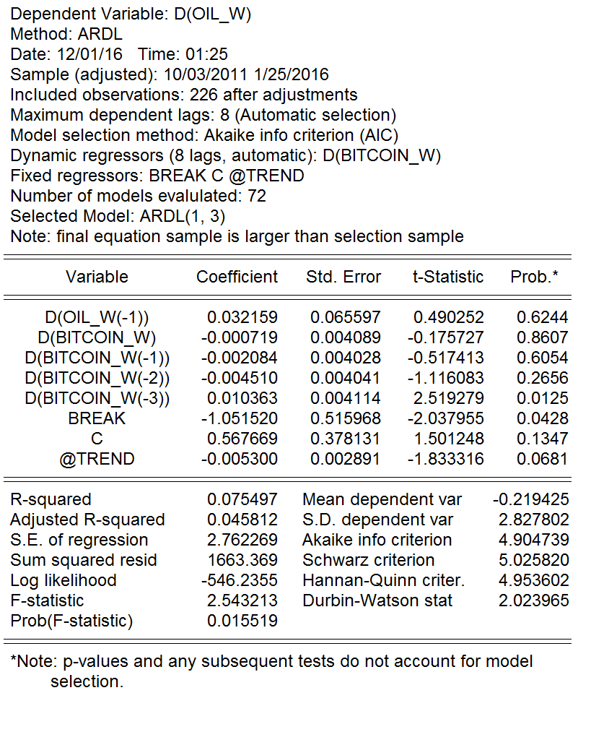

### SERIAL CORRELATION

It's important that the errors of this model are serially independent - if not, the parameter estimates won't be consistent. To that end, we can use the Q-STATISTICS to check for the serial correlation, and this gives us the following results.

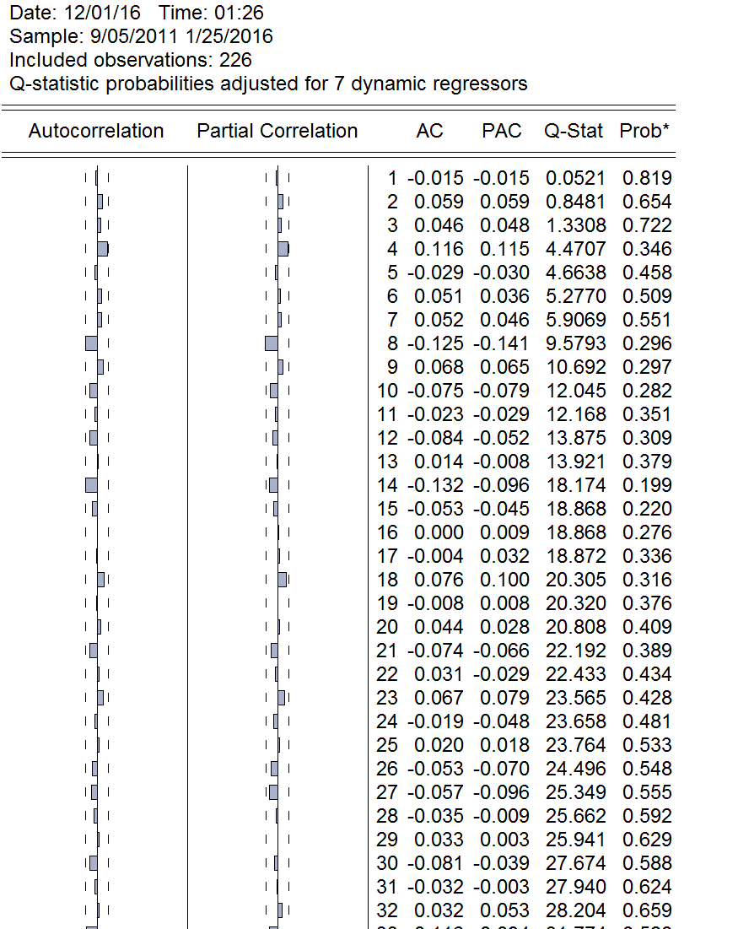

The p-values strongly suggest that there is no evidence of autocorrelation in the model's residuals.

### TEST FOR LONG RUN RELATIONSHIP

One of the main purposes of estimating an ARDL model is to use it as the basis for applying the "Bounds Test". The null hypothesis is that there is no long-run relationship between the variables - in this case, crude oil and bitcoin.

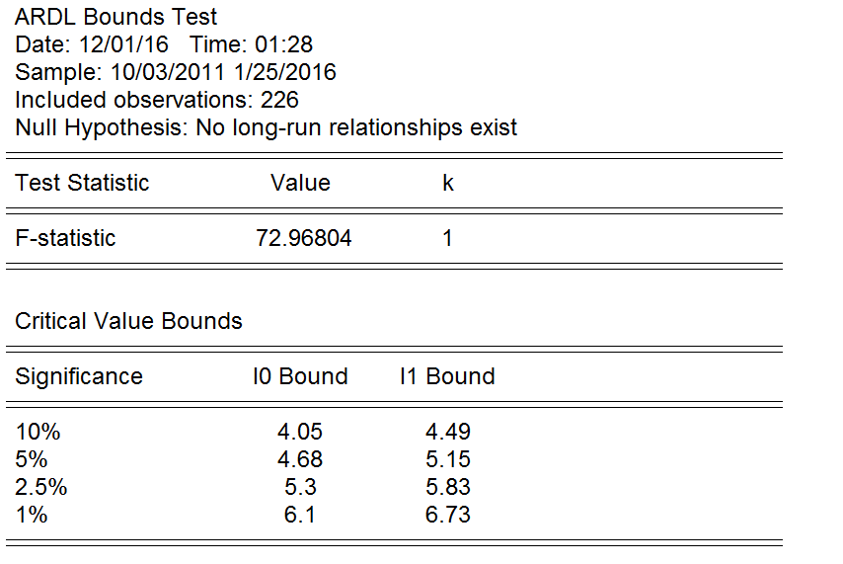

A high F-static value indicates that a long run relationship exists between crude oil and bitcoin.

### COINTEGERATION AND LONG RUN FORM

Testing for co-integration and long run form we can see that the cointegration equation is quite significant and the error-correction coefficient is negative (-0.959). The long-run coefficients from the cointegrating equation are reported, with their standard errors, t-statistics, and p-values.

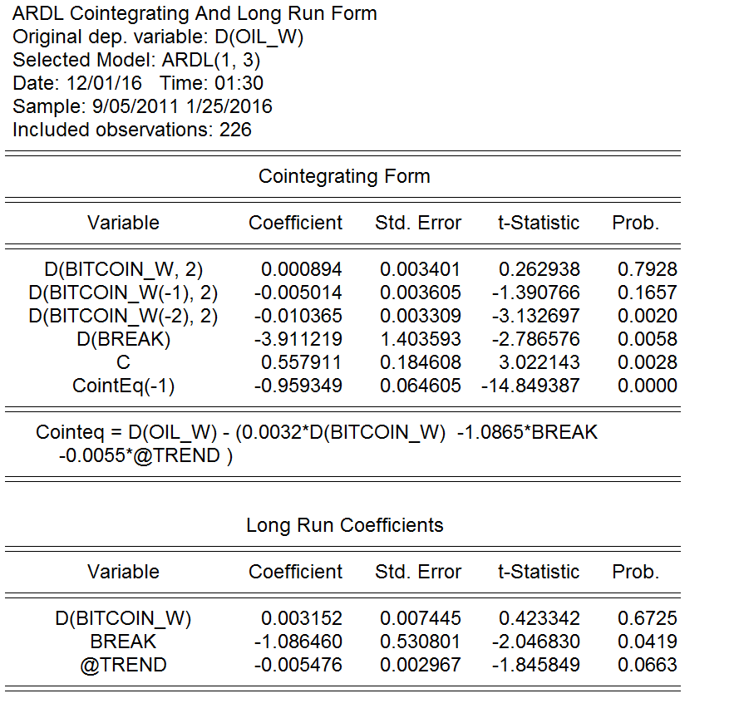

# UNIVARIATE ANALYSIS OF BITCOIN

## HISTOGRAM

On plotting the histogram, the data exhibits a kurtosis of 17.09 which clearly says the distribution is not normal, but it is leptokurtic.

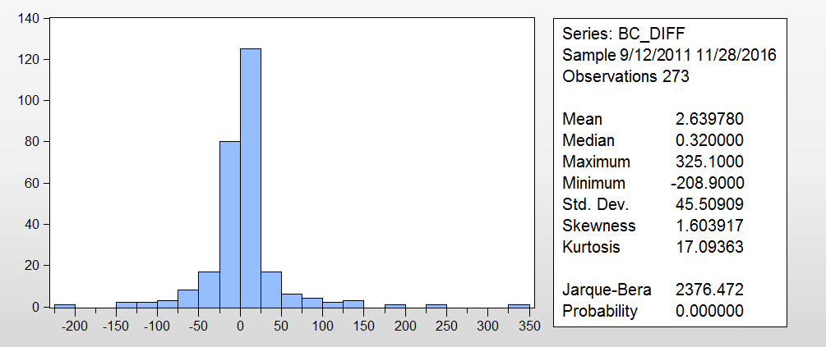

## TESTING VOLATILITY CLUSTERING

To examine the presence of volatility clustering, we ran a regression of the first difference bit coin price and constant, and then ran a test for heteroskedasticity. The residual plot shows large fluctuations at certain parts of the data.

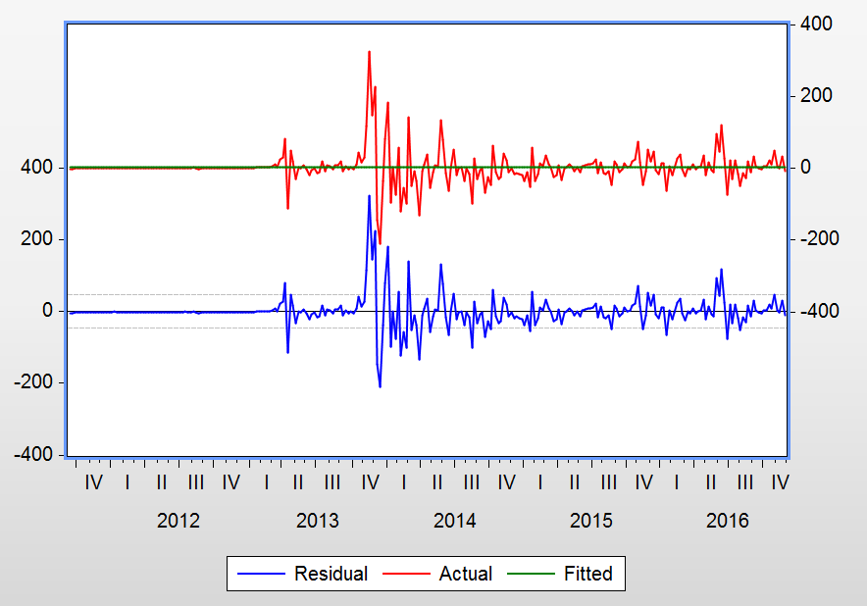

## MODEL SELECTION

We ran the following ARCH/GARCH models and selected the one that the least AIC and SIC scores.

|  |  |  |
| --- | --- | --- |
| **MODEL** | **AIC** | **SIC** |
| **ARCH 1** | **9.49** | **9.54** |
| **ARCH 2** | **8.57** | **8.63** |
| **ARCH 3** | **7.83** | **7.91** |
| **ARCH 4** | **7.52** | **7.61** |
| **ARCH 5** | **7.49** | **7.60** |
| **GARCH (1,1)\*** | **7.50\*** | **7.56\*** |

* Best Model

## MODEL ESTIMATION

The GARCH (1,1) model was estimated for Bitcoin sampling just the time period 9/12/2011 to 11/23/2015, and the following statistical inferences were obtained.



Estimation Equation:

=========================

BC_DIFF = C(1)

GARCH = C(2) + C(3)*RESID(-1)^2 + C(4)*GARCH(-1)

Substituted Coefficients:

=========================

BC_DIFF = 0.0490868635154

GARCH = 0.0128152265882 + 0.892205093166*RESID(-1)^2 + 0.569459038953*GARCH(-1)

## MODEL FORECAST

Using the estimates, we then forecasted the data between 11/23/2015 and 11/21/2016 and found the forecasts to approximately follow the pattern in the original data for that period.

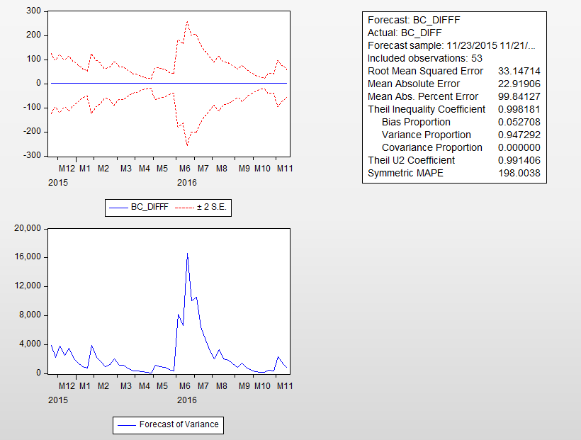

# CONCLUSION

In this paper, ADF break point unit root test, cointegration analysis, impulse response functions are adopted to construct VAR model. Granger causality tests is used to estimate ARDL model. Also, a univariate analysis is established to know the effect of past values on bitcoin. It mainly analyzes the influence of oil price on bitcoin price. The empirical research shows that oil price and bitcoin daily trading volume have a stable long-term relationship with the price of bitcoin, and in the short term, bitcoin price has the dynamic mechanism to adjust to the long-term equilibrium level. Changes in bitcoin prices have little impact on oil prices, this might be because bitcoin being a form of currency has the potential to affect the prices of commodities. The high volatility in the bitcoin price is the basis for estimating the arch/garch effect in the model.

Generally speaking, bitcoin daily trading volume can reflect the degree of investors’ attention to bitcoin, the more active the bitcoin market is, the higher the price. The high volatility of its price makes it difficult to consider it as a good investment. Also, the attitude of number of governments on bitcoin shows that development of digital currencies is likely to be limited. In addition, bitcoin has exposed many security risks in the process of rapid development. That is to say, future development of bitcoin faces great uncertainty. If the investment environment of bitcoin can be improved by legislations, bitcoin will become a legal investment product. Then people will recognize the value of bitcoin and the bitcoin investment market will move toward the rationality, which would be a good complement to the stock market [2,3].

# References:

[1] Briere M,Oosterlinck Szafarz A. Virtual currency, tangible return: portfolio diversification with bitcoins. Tangible Return: Portfolio Diversification with Bitcoins (September 12,2013),2013

[2] Guo,Di. Research on the development prospect of bitcoin. Securities & Futures of China, Vol. 07 2013.

[3] Cai,Zhihong. The development, possible influence and supervision progress of digital money. Financial Development Review, 2015(3):133-138.